5.01 Male to Female Population Ratios Worksheet

Demographers frequently need to simulate events that affect human populations ranging in size from a few 100 people all the way up to an entire country (or even the world).

In 2006, the world population was estimated at 6.5 billion people. The distribution by age and gender are indicated in the following table.

Age | Male | Female | Total
0-14 | 919,219,446 | 870,242,271 | 1,789,461,717
15-64 | 2,152,066,888 | 2,100,334,722 | 4,252,401,610
> 65 | 213,160,216 | 270,146,721 | 483,306,937
Total | 3,284,446,550 | 3,240,723,714 | 6,525,170,264
Percent | 50.34% | 49.66%

Demographers calculate the population ratio of males to females according to the following formula.

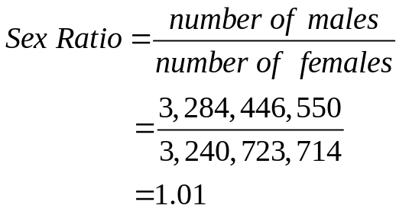

A value of 1.00 means a 50:50 male to female ratio; greater than 1.00 indicates a higher percentage of males; less than 1.00 indicates a greater percentage of females. The sex ratio varies slightly among countries for a variety of reasons (e.g. health, environment, culture, etc.).

The CIA World Factbook contains population demographics for every country in the world. An excerpt from the web page for Taiwan, Dr. Lin’s country of origin is shown below. Notice the location of information about Taiwan’s population size, age structure, and sex ratio.

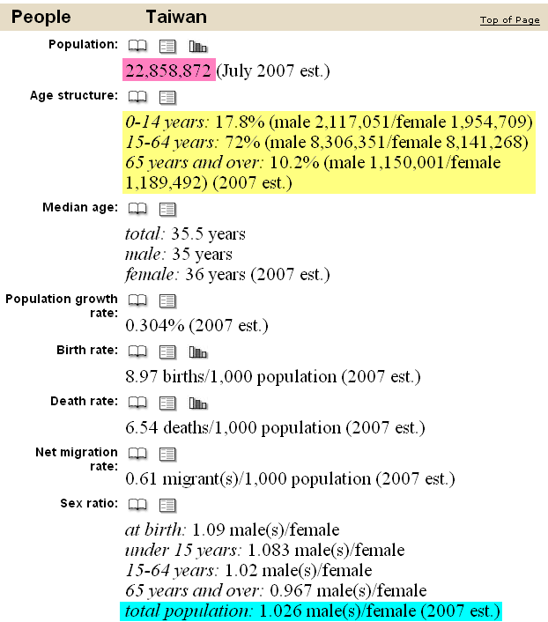

5.01 Male to Female Population Ratios Worksheet

Name: __________________________ Date: ______________

Submit the following two tables with your program for Assignment 5.01.

Pick a country in the CIA World Factbook and fill in the information missing from the following table. Pick a country based your national origin or simply one in which you have an interest. Don’t forget to record the Male:Female ratio reported in the Factbook to determine the accuracy of your simulation.

Country: ____________________________________ Male:Female ____:____

Age | Male | Female | Total
0-14
15-64
> 65
Total
Percent

Use the data in the table to calculate and verify the male to female ratio for the country you chose. You will need the percentages in the program for this assignment. You can calculate the averages with a calculator after gathering data from your program simulation.

Simulation of The Ratio of Males to Females for: __name of country goes here__

 | 10x | 100x | 1000x | 10000x
Males
Females
Males
Females
Males
Females
Males
Females
Males
Females
Avg. Males
Avg. Females

